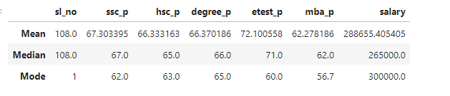

This is placement data. The expectation is to feed this data into ML model to check what salary can be expected in the future. Before ML, we are analyzing the data to find patterns.

Mean:

* 10th average pass mark is 67, which means the students scored an average of 67 in their 10th standard. So the student have performed averagely.
* Similar to 10th, 12th standard performance was also average.
* Students performed slightly better (good) in Entrance test (in comparison to 10th and 12th)
* Again in MBA, the student performance has dropped
* The average salary is 288655

Median (OUTLIERS are removed):

* 10th results is similar to mean
* 12th results is similar to mean
* Entrance test results is also similar to mean
* MBA performance is similar to mean
* Only the salary is slightly lower, which means the dataset had outliers which were removed

Mode

* 62 was commonly scored by 10th students
* 63 was commonly scored by 12th students
* 65 was commonly scored in entrance exams
* 56 was commonly scored in MBA exams
* Most commonly earned salary by most students was 3 lakhs

Overall, the students of this class are average performers. Entrance test was slightly better than other exams. Outliers was found in salary details.